Product Inventory Management System
Ideation Phase
Define the Problem Statements

Date | 07/03/2026
Team ID | SWTID-2026-6317
Project Name | Product inventory management
Maximum Marks | 2 Marks

Customer Problem Statement Template:
The Customer Problem Statement identifies the difficulties users face while managing product inventories. Understanding user needs helps the team design a system that is simple, secure, and efficient. Based on these insights, the project aims to develop a practical inventory management solution using the MERN stack.
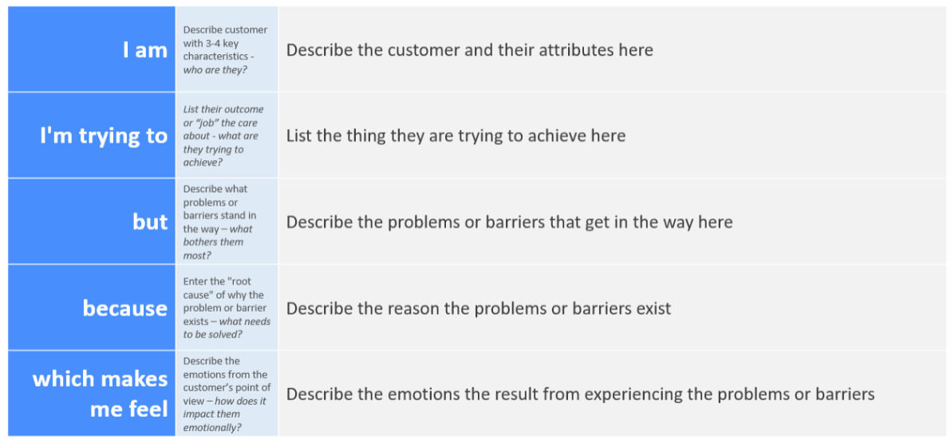
Reference: https://miro.com/templates/customer-problem-statement/

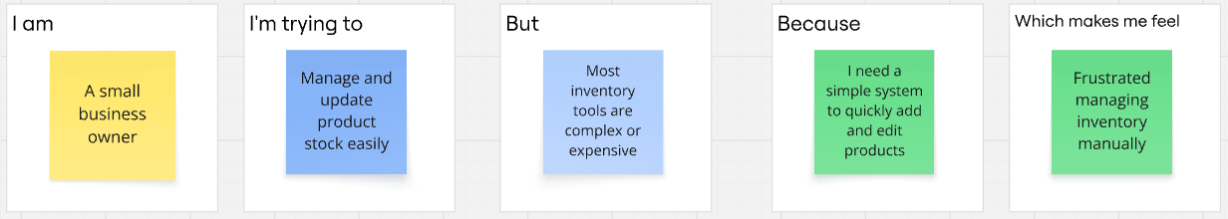
Problem Statement | I am (Customer) | I’m trying to | But | Because | Which makes me feel
PS-1 | A retail shop owner | Monitor and control product stack | Managing records manually takes lot of time | I need a simple system to quick add edit and remove the product | Tired of handling inventory manually
PS-2 | A freelancer selling products online | Track available items and pricing | Data gets lost without a centralized platform | I want a secure dashboard where only I can manage my products | Stressed about losing important product data
PS-3 | A shop manager | Update stock quantity regularly | There is no easy real-time CRUD system | I need a fast and responsive web app to update inventory anytime | Anxious when stock information is outdated
PS-4 | A startup business owner | Organize and maintain product details | Many inventory tools are complex to understand | I want a simple and easy to use inventory system | Overwhelmed by complicated software

